Lab 4  
  
A_1:  
  
A_2:  
  
A_3:  
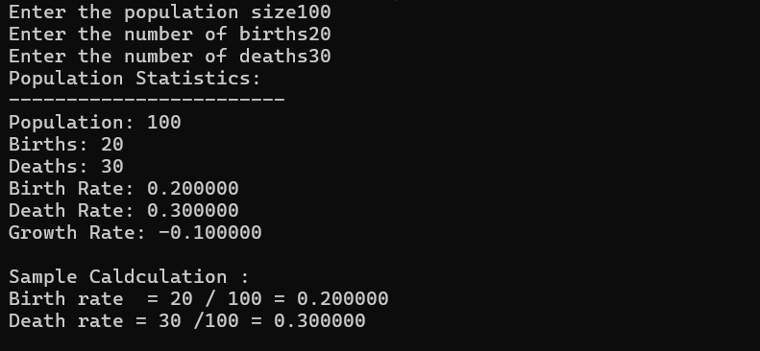  
  
A_4  
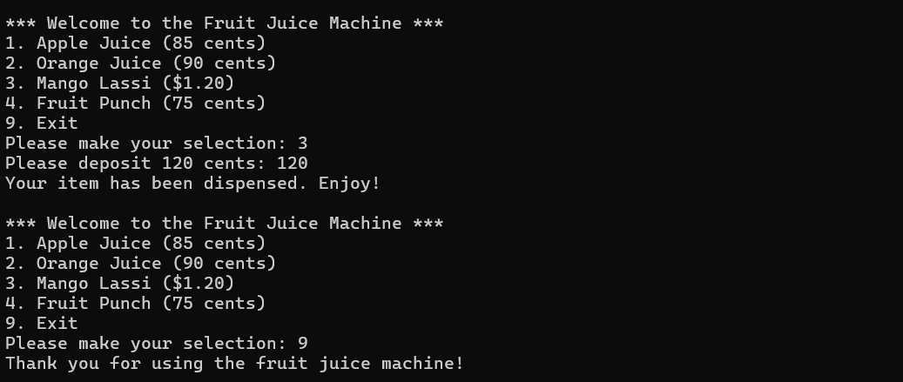  
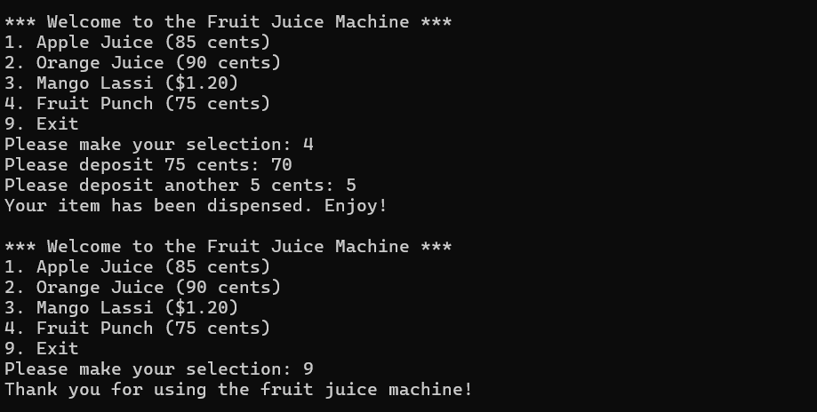  
  
B_1  
  
B_2_1  
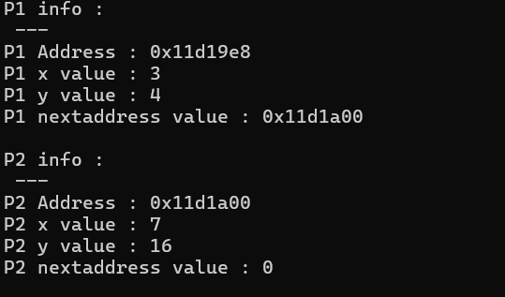  
B_2_2

